SHARE YOUR ROAD PROFILE WORK BOOK
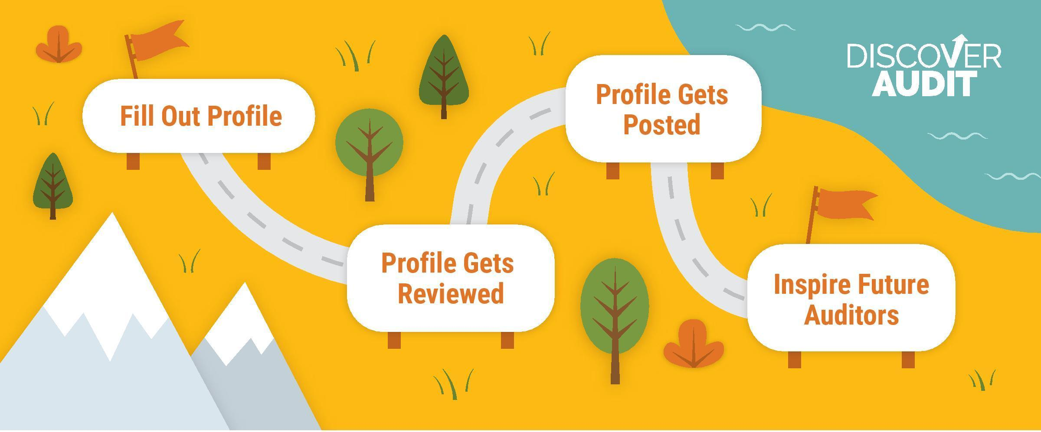
Everyone has a story about how they got to where they are today — and every story holds lessons.

Share Your Road is a career advice site that shares the stories and advice of professionals with career-seekers of all ages. Professionals answer questions about their career journey to help others figure out their own, creating a story people can learn from as they explore different paths and possibilities.

This is where you come in! We’re asking you to “Share Your Road” and tell your own career journey that has lead you to a career in audit. This is a valuable opportunity to help bring more awareness about the attractiveness of a purpose driven career in audit to a growing community of 10,000+ schools and 14 million students across the nation.

Completing a full profile is a simple process and should take no longer than an hour to complete. An initial profile can be completed in less than 20 minutes, however you will need to return to the site to complete your full profile at a later date.This guide will walk you through all of the questions you’ll be asked. When you’re ready to ‘Share Your Road’ please visit discoveraudit.shareyourroad.com

THE ELEMENTS OF YOUR WORK
Tips: In this section you’ll be asked to pick 3 characteristics that will help future auditors understand what goes into your work. Consider highlighting things that have surprised you about your career in audit!

At its core, every job connects to a fundamental motivation-something that bring it meaning and purpose. What drives your work? (Select one answer) | - Accomplishing Goals  - Being Creative  - Being Physically Active  - Building Things  - Communicating/Sharing Stories  - Helping people  - Working with Others | - Learning/Being Challenged  - Problem Solving  - Teaching/Mentoring  - Upholding a Cause and Belief  - Working Independently

People are more likely to enjoy their work if it involves something they like to do. Select the interest most closely related to your work and help others who share your interests discover your career. (Select one answer) | - Acting & Theater  - Action Sports  - Armed Services  - Art  - Business  - Design  - Education  - Engineering  - Entrepreneurship  - Environment & Nature | - Fashion  - Film  - Food  - Government  - Journalism  - Law  - Medicine  - Music  - Non-Profit Organizations  - Numbers | - Politics  - Philosophy & Religion  - Radio  - Science  - Sports  - Technology  - Television  - Travel  - Writing

Most jobs don’t exist in a silo; they’re multidisciplinary roles that combine different interests. What other interest does your work incorporate? (Select one answer) | - Acting & Theater  - Action Sports  - Armed Services  - Art  - Business  - Design  - Education  - Engineering  - Entrepreneurship  - Environment & Nature | - Fashion  - Film  - Food  - Government  - Journalism  - Law  - Medicine  - Music  - Non-Profit Organizations  - Numbers | - Politics  - Philosophy & Religion  - Radio  - Science  - Sports  - Technology  - Television  - Travel  - Writing
YOUR EDUCATION
Tips: In this section we will show future auditors that there are many paths to a career in audit. Provide guidance that shows the variety of different educational paths people take to get to a career in audit.

- Now let’s think back. Walk us through the education or training you’ve received. (List in chronological order from oldest to most recent.) - Populate all that apply
- High School [Didn’t complete high school] [GED]
- Undergraduate Institution and Major/Degree
- Graduate Institution and Major/Degree
- Doctorate Institution and Major/Degree
- Institution/Program Name and Certification/License

- How related were your studies to the work you do now?

⃝ | ⃝ | ⃝ | ⃝ | ⃝
Not Related |  | Somewhat Related |  | Very Related

- For someone aspiring to be in your job, would you recommend they follow your same educational path?
⃝ | ⃝
Yes | No

- What’s the ideal educational path you’d recommend for someone aspiring to be in your job? - Add undergraduate major or degree

DISCOURAGEMENT YOU FACED
Tips: Future auditors may face some setbacks. Help them out by shedding some light on some of the negative feedback, misconceptions or discouragement you may have heard throughout your career. Take an open and constructive approach to this section.

We all face criticism from others—and maybe even ourselves—about our choices and aspirations. Some of it is well-meaning, while some of it is just negative noise. But all of it can steer us away from what we really want to do. Please share the discouragement you heard on your road.

- I heard… (255 characters)
Who said this?  Select 1 answer | - Parents  - Family  - Friends  - Peers  - Teachers | - Society in general  - I said this to myself  - I’d rather not say
- Help someone who is facing similar discouragement by sharing how you dealt with the noise you heard (and might still hear to this day!) (500 characters)
YOUR WORK LIFE
Tips: Future auditors are curious to know what a day in-the-life may look like. Help them out by giving them a window into your day!
- For those who are interested in the nuts and bolts of what you do, describe what a typical day at work looks like. (500 characters)
- Most technical skills are gained by hitting the books. Thinking beyond what's learned in school, what other experiences, qualities, or skills are helpful to succeed in your job? (500 characters)

YOUR HURDLES & YOUR LIFE ROUTE
Tips: Help future auditors understand your own career trajectory along with any big wins or major hurdles you encountered along the way.

- Some life routes are linear, while others zigzag. Which best describes the road you took to get to where you are?
- It was straightforward | - It took a while to figure out | - I tried a bunch of things

- Life isn't a straight line to a goal. It's packed with twists and turns that can steer us to a totally unexpected place—a place that's almost always more fulfilling than anything we could have planned.

Jot down, in chronological order, some pivotal steps in your life—from struggles to triumphs—and help others see that the road to success isn't always as straightforward as it appears, but that's OK. (Up to 8 entries – 200 characters each)

DISCOVER AUDIT INSIGHTS
Tips: We’ve got some questions that will help career seekers better understand your own experience in audit.

- How did you first come to discover audit as a career path? (500 characters)
- What advice would you give to your younger self about pursuing this career path? (500 characters)
- What do/did you appreciate most about being an auditor? (500 characters)
- What are the more common misperceptions that people have/had about your job as an auditor? (500 characters)
- What is your favorite benefit or unexpected perk of having a career in audit? (500 characters)

FIRST STEPS
Tips: This is your chance to help someone on their path! Consider sharing something that you don’t think a student could find from a simple Google search.

- Once you have an idea of what to do with your life, it can be tough to figure out how to start pursuing it. For someone who's ready to break into your career, what's the first step you recommend to get their foot in the door? (500 characters)

Who would this advice be best for? (Select one) | - Middle school students  - High school students  - College students | - Professionals  - Everyone

STAY IN TOUCH
Your road doesn’t end here! Help future auditors get in touch and take some time to spread the word about this great initiative.

Your road doesn't end with this experience, so help others keep up with where you're going! List your social media accounts below and we'll display them on your profile so people interested in following you can stay in touch—and stay inspired. - Complete all applicable
Twitter: @
Instagram: @
LinkedIn:
Facebook:
Personal website or blog:

Once you’ve completed your profile click finish. You’ll receive a message indicating that your profile will be reviewed, and e-mail notification will be made when review is complete.

When your profile is up and ready – share it with someone who you think could benefit from seeing your path!

